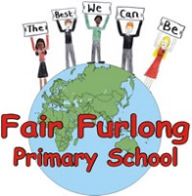
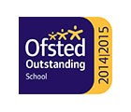
FAIR FURLONG PRIMARY SCHOOL
Tel: 0117 377 2181
‘The best we can be’

5th May 2020
Dear Parents and Carers,
We hope that this letter finds you all well and that home learning is manageable for you. If you have any trouble or need any support please use the year group emails and staff will be happy to help you.
We have recently contacted families who have not been in touch to offer support and check in and can see that not all children are accessing Bug Club and Times Tables Rockstars (or Google Classroom in Y4-6). Please contact us if you need us to send your log-ins again.
School staff are busy writing school reports that we will send out in July. We are also planning for our eventual return to school and operating the provision for key worker children. Our Governors meetings continue to run almost as normal with meetings being held virtually this term and next.
On Friday it is the 75th anniversary of VE day. Please do all you can from home to honour the sacrifice of this generation and celebrate this special day in history. We have shared online resources on the Home Learning page on our website.
As yet we do not know any details of the government’s plans to return children to school. Behind the scenes the school leadership team have been planning and preparing as best we can and while we have been closed to most pupils the school has been deep cleaned.
We await more details from the DFE and will share with you our plans as soon as practicably possible. In any planned return the safety and wellbeing of our community will be our first priority.
We really do miss our school community. Take care and continue to follow the government advice to stay safe. We know that this has been an extremely challenging time for everyone.
Kind Regards,
Mrs Lang

