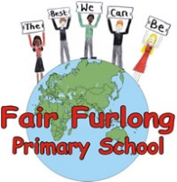
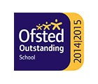
FAIR FURLONG PRIMARY SCHOOL
Tel: 0117 377 2181
‘The best we can be’

23rd April 2020
Dear Parents and Carers of children in year 4,

Traditionally there has been a camp for our year 5 children early in the new school year. This has already been booked for the second week back in September, however in view of the circumstances I have no option but to cancel this booking for the time being.
There are several reasons for this but my prime consideration is the safety of our children and staff. We do not know what the guidance will be in September regarding social distancing but it is likely there will be some form of restrictions in place which may mean we can’t take children away in a large group overnight. Also, in order to run camp effectively we would need to make bookings and payments and start collecting deposits now and further payments over the summer term. I do not want families to feel the financial burden of this at this time.
This will be a disappointment for many of our children who look forward to this event so I will do my best to make some alternative arrangements for later in the year but this will be dependent on ensuring safety first and then being able to secure a booking at an appropriate place.
I hope you appreciate the reasons for this very difficult decision.
Take care, stay safe and see you all soon.

Mrs Lang

