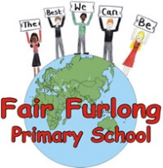
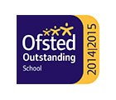
FAIR FURLONG PRIMARY SCHOOL
Tel: 0117 377 2181
‘The best we can be’

3rd April 2020
Dear Parents, Carers and Children,
I do hope you are all staying well and following the guidance to stay indoors as much as possible. These are, without a doubt, difficult times but I am sure you recognise it is essential to follow the guidelines. I hope you are beginning to find a bit of a new routine to keep each other busy and trying to have some fun together.
The teachers have been overwhelmed by the dedication of the children and everyone at home in working through some of the tasks they have set and staying in touch. Thank you all. Keeping a connection with the children is important to all of us at school and I hope that you have found it supportive too. We currently exist in much more of an online world with conversations and learning happening in different ways but it does not mean we care any less about how everyone is doing.
Please do continue to be mindful of using the internet and these communication tools in a safe way. If anyone needs any further support around e-safety, financially or with food please have a look at our website for some useful contacts. If you have a safeguarding concern please call First Response on 0117 9036444.
School is closed over the Easter holiday break so we will resume our support for Keyworker families after that. Again thank you for protecting our staff and children by keeping your children home if you can. Once I know more from the government about reopening I will of course let you know, in the meantime I am busy planning a way for you come in to swap reading books safely. If there is anything else we can do to help, get in touch with school via email or phone on a normal school day.

Kind regards,

Mrs Lang

