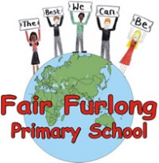
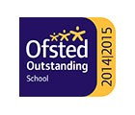
FAIR FURLONG PRIMARY SCHOOL
Tel: 0117 377 2181
‘The best we can be’

19th March 2020 6pm

Dear Parents and Carers,
Schools in England will be closed from the end of the school day tomorrow. We will close after the end of after school club at 4:15pm.
Thank you to those of you who managed to collect home learning packs today and especially to those doing a pick up for other families. It is great to see everyone being so supportive of each other in these tricky times. If you have yet to collect a pack for your child please try to do so by the end of the day tomorrow. The children who were in school today should have come home with one. In the pack is a letter with your year group email address to stay in touch with your child’s teacher.
We have been busy compiling a list of families where both parents are key workers (although the formal list of what those roles are has still not been released). Please be patient as we try to come up with an offer of support which helps as many of our staff as possible to limit contact whilst also helping essential services to continue. I expect to be able to provide more detail tomorrow about the offer we can provide for the children on the list. Please note that due to staffing limitations we will be unable to offer breakfast club or after school club.
We have been notified that Bristol City Council and their catering providers have organised meals for children entitled to Free School Meals (this is not all children up to year 2 but only those who are registered for FSM). The meals will be in the form of a five-day pack of packed lunches which will be available on a Monday. We are able to collect the meals from Four Acres (which is the local catering hub) from 11am and then deliver them. Please note this may take some time as we have over 90 drop offs.
Many thanks for all the kind words of support as we continue to do our best.

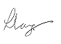

Mrs. L. Lang Mrs J. Skinner
Headteacher Chair of Governors

