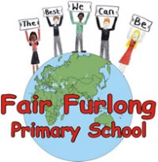
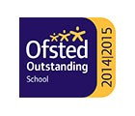
FAIR FURLONG PRIMARY SCHOOL
Tel: 0117 377 2181
‘The best we can be’

18th March 2020 5:45pm

Dear Parents and Carers,
Schools in England will be closed from the end of the school day on Friday.
We have activities prepared in a folder for each child. Also, to support home learning, teachers will be communicating with their classes via the email address you have provided to school. PLEASE ENSURE WE HAVE AN UP TO DATE EMAIL ADDRESS FOR YOU. A test email was sent today – if you did not receive it please call the school office to update your details.
If your child is already at home in isolation, we will be in touch with you regarding collecting work from the school. If your child is in school the work will be sent home with them tomorrow (Thursday).
For some families continued support from the school can be provided. If you believe that your child requires continued care due to your role as an identified key worker, your family is not in isolation and you have no other care options, please let us know by contacting the school office. We will compile a list to be able to plan some provision for those children once we know how many there are and their age groups.
I will update you further once more details become clear and we have been in contact with Bristol City Council and our catering provider regarding the provision of food for those of you entitled to Free School Meals. We recognise that even food may be a challenge for many of our families so are also investigating being able to provide a donated food collection point.
In the mean time I look forward to seeing some of you tomorrow. Please reassure your children in this difficult time.

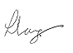

Mrs. L. Lang Mrs J. Skinner
Headteacher Chair of Governors

