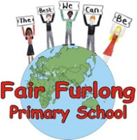
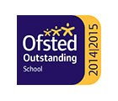
FAIR FURLONG PRIMARY SCHOOL
Tel: 0117 377 2181
‘The best we can be’

17th March 2020
Dear Parents and Carers,
In light of the most recent update from Public Health we ask that all children displaying symptoms of a new, continuous cough or a high temperature isolate at home for 14 days. Anyone also in a household where someone is experiencing the symptoms should also isolate, therefore we request that brothers and sisters of children in isolation are also kept at home.
Please tell us about any absences as usual by calling the school office so we can ensure our records are accurate.
The care of our children, families and staff is our priority so further measures will also be implemented in school to limit contact beyond the core teaching activities. This means that there will be no offsite trips other than swimming for the time being, no whole school assemblies and events where additional people may be on the school site, such as reading café, stay and play and sports events have been cancelled. We had already suspended our visits to Murford Nursing Home to protect the residents.
The performance for years 2 and 3 next week will no longer be for families to come and see, instead the children will perform for a small audience in school and we will try our best to video record the performance to share with you. Children who do not have permission to have photos/video on the website will not be shown on screen.
Whilst we understand the adjustments in these school events may be disappointing for some of you, for others I am sure it will be a relief that our priority is to reduce the risk of the spread of the virus in our community. However, we must reiterate that we have no confirmed cases of Coronavirus in school. We do have some children and staff who are self-isolating.
For children off of school we have activities prepared in paper form. In order to support our home learning set up please ensure we have an up to date email address for you that your child/children could use to receive and send work to and from their teachers.
We will keep you updated if the situation or advice changes but please do continue to check the websites https://www.nhs.uk/conditions/coronavirus-covid-19/ and https://www.gov.uk/government/topical-events/coronavirus-covid-19-uk-government-response for current updates.
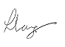

Mrs. L. Lang Mrs J. Skinner
Headteacher Chair of Governors

