|  |
| --- |
| **NEWSLETTER  7 April 2017**  **This week at Fair Furlong** |



Wishing you all a very happy Easter. Well done to all the children for their hard work during this term we have all had a very busy spring term. Don’t forget Easter challenges in the holidays.

**We look forward to seeing you back on Monday 24th April.**



**This Easter we have a very special Fair Furlong wedding – Mr Lang will be marrying Mrs Edwards and so from the beginning of Term 5 we will have both Mr and Mrs Lang on our staff team. The children enjoyed celebrating with them this week and we all wish them a lovely wedding day.**

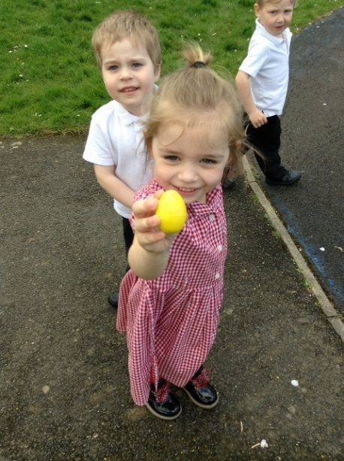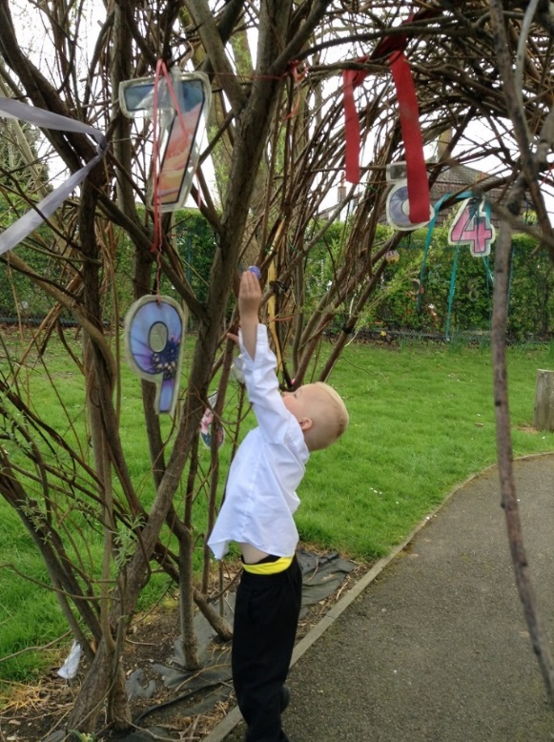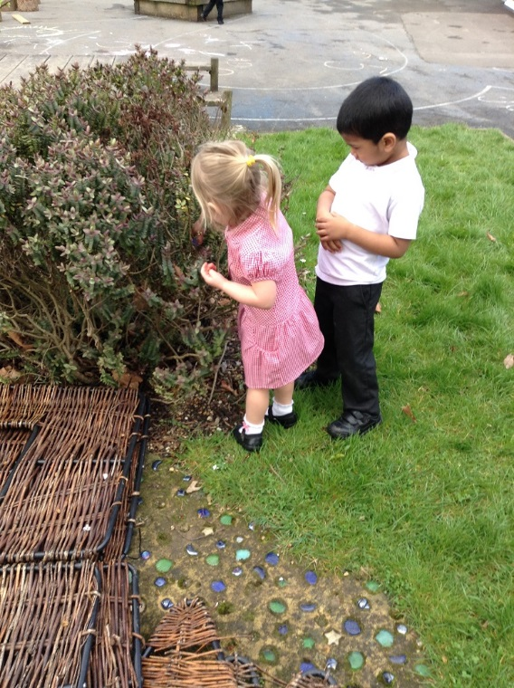**Nursery Egg Hunt** - Nursery have been learning all about Easter, we decorated cards, the Easter bunny hid his eggs in our garden and we decorated our own eggs to roll down the hill in the playground. Dalton's got the furthest. What a busy week!

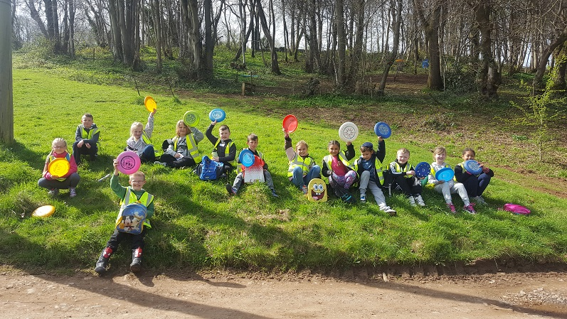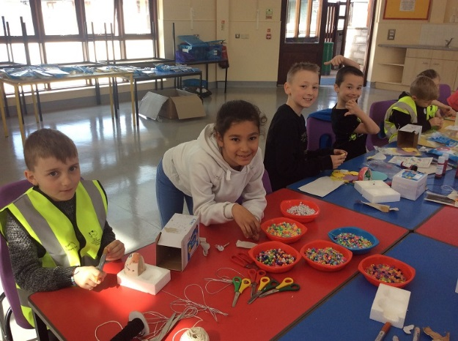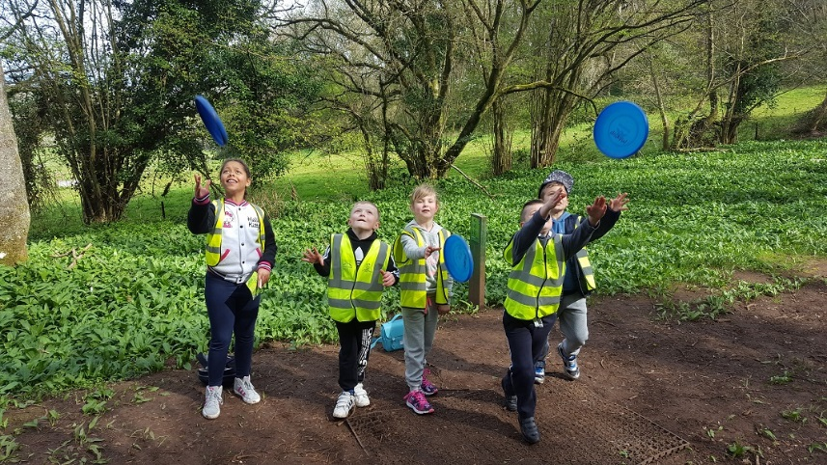**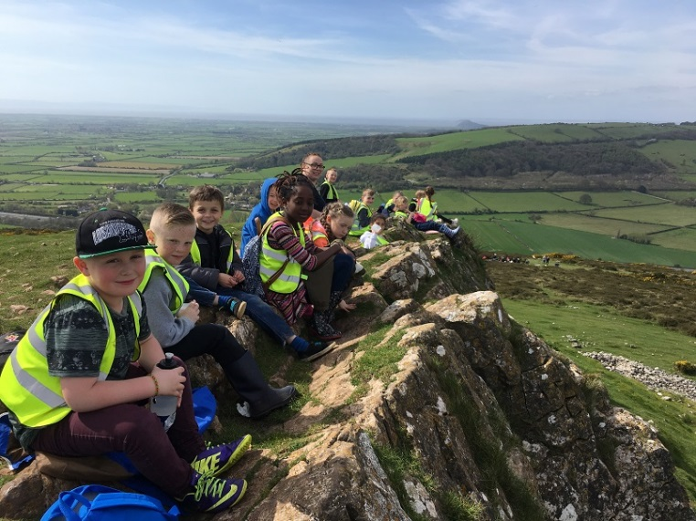Barton Camp –** The children have had a brilliant camp. They were very lucky to have beautiful sunny weather the whole time so could enjoy lots of time outside. They’ve had a great time playing Frisbee golf, doing archery, swimming, walking and being creative in arts & crafts. More photos in school and on the website!

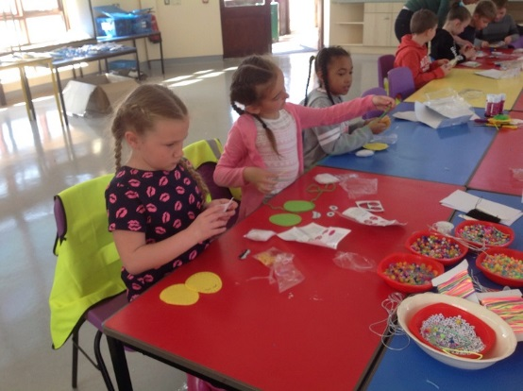

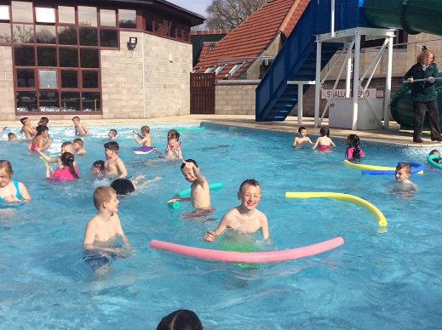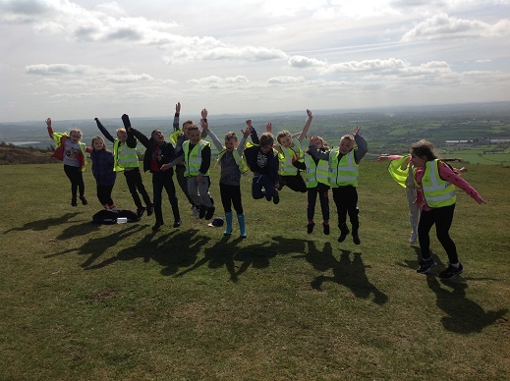

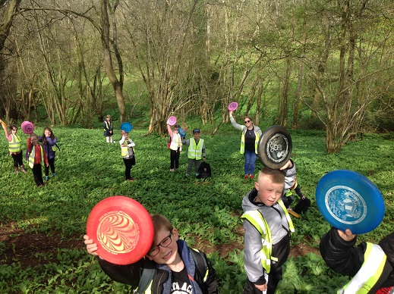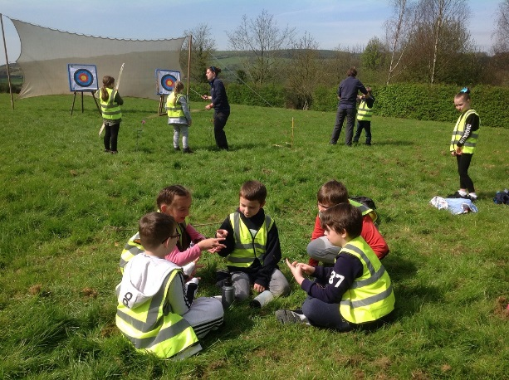

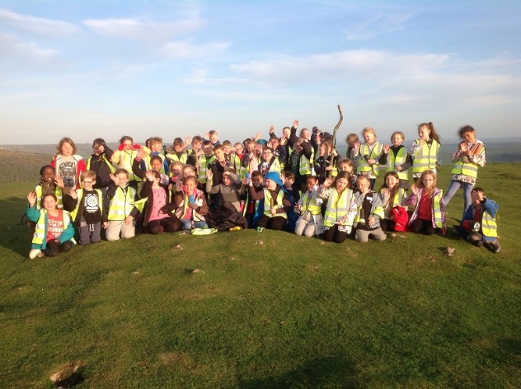

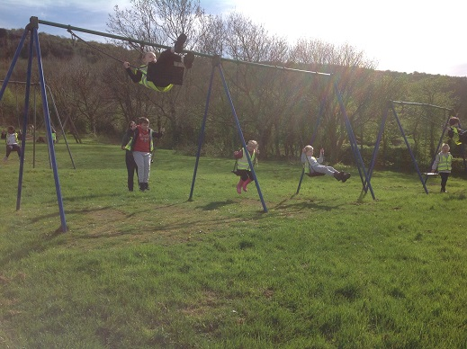

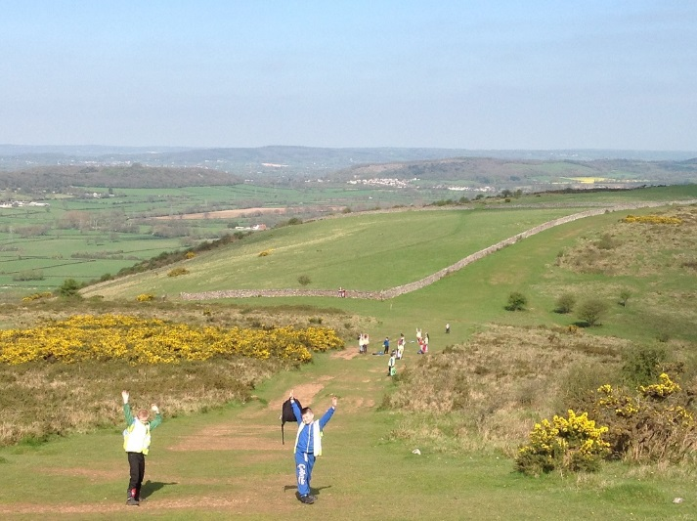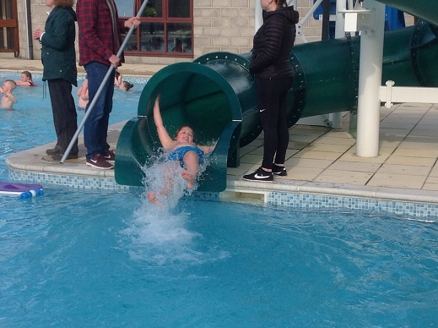

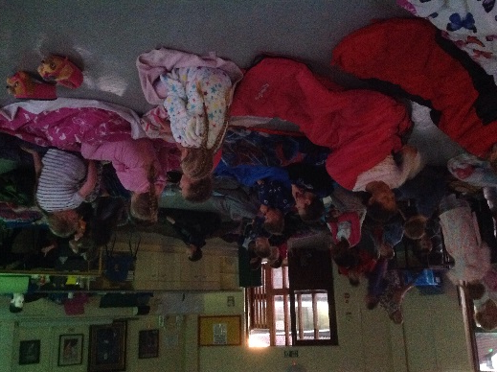

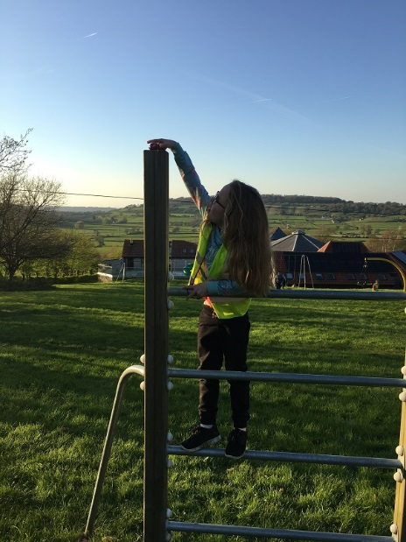

|  |
| --- |
| **Cruz in year 6 has been helping Miss Drew come up with some ideas about how children should behave outside of school. He has come up with these 6 very good and thoughtful rules:**   * **Be kind to people** * **Keep your hands to yourselves** * **Play nicely out of school** * **Treat each other with respect** * **If you see an old person struggling do something to help them** * **Have good manners Well done Cruz** |

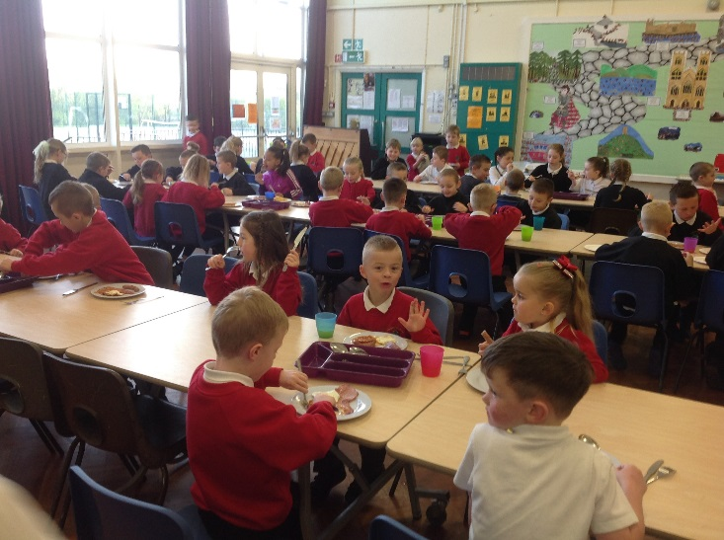Our theme in breakfast club and lunch today was English food and the children enjoyed a delicious English cooked breakfast this morning and a yummy ploughman’s for lunch.

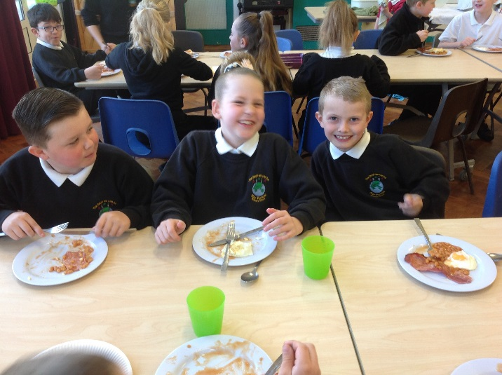

Best attendance for last week went to Balmoral with a brilliant 99.2%!!! Let’s try and make it 100 next week! Also New Forest who had an amazing 97.2%

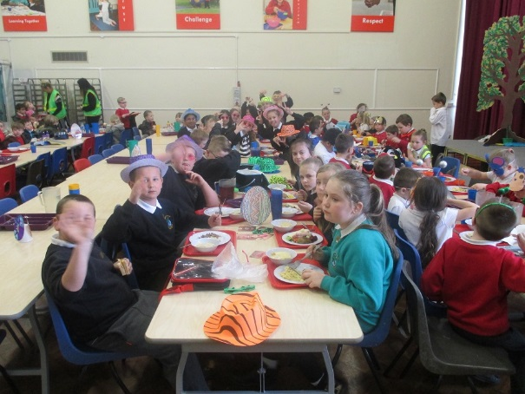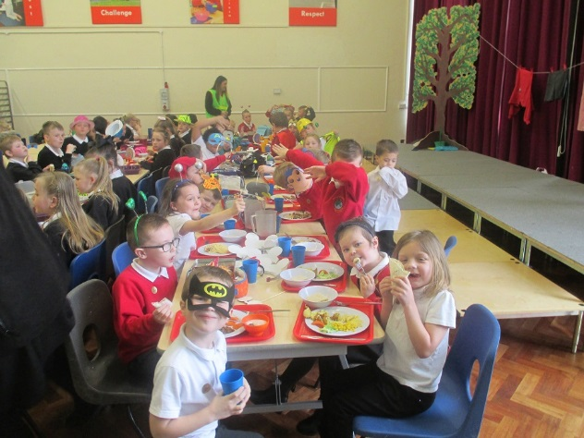

**ATTENDANCE IN SCHOOL THIS WEEK:   
KS2 KS1**

|  |  |  |  |  |  |  |  |  |
| --- | --- | --- | --- | --- | --- | --- | --- | --- |
| ***Position*** | | ***Class*** | ***% Attendance*** | | ***Position*** | ***Class*** | ***% Attendance*** | |
| **1st** | | **Glastonbury** | **95.2%** | | **1st** | **Brighton Pier** | **98.7%** | |
| **2nd** | | **Fingal’s Cave** | **94.7%** | | **2nd** | **Hadrian’s Wall** | **98%** | |
| **3rd** | | **Jorvik** | **93.8%** | | **3rd** | **Stonehenge** | **96%** | |
| **4th** | | **Ullswater** | **92.7%** | | **3rd** | **Forest of Dean** | **96%** | |
| **4th** | | **Penzance** | **92.7%** | | **5th** | **Snowdon** | **95.8%** | |
| **6th** | | **New Forest** | **92.4%** | | **6th** | **Balmoral** | **95.4%** | |
|  | |  |  | | **7th** | **Caenarfon** | **95.3%** | |
|  | |  |  | | **8th** | **Tintagel** | **92%** | |
| **Attendance** | | | **Comment** | | | |
| **99% - 100%** | | | **Outstanding** | | | |
| **97% - 98%** | | | **Excellent** | | | |
| **95% - 96%** | | | **Great (School attendance target is 95%)** | | | |
| **93% - 94%** | | | **Satisfactory** | | | |
| **Less than 93%** | | | **Must do better** | | | |

**MCj00787910000[1]AWARDS:** **Maths Badges:** Tommy Laird; Sande Amollo; Joshua Penny; Zachary Campho-Smith; Freya Bedford; Kayden-Ronnie Nelson; Callum Munford; Samantha Sherwell; Reece Boulton; Ashleigh Gould; Jayden Owen; Connor Grouvel; Shinade Devey; Mitchell Plant; Paige Thatcher; Alyssa Phillips; Tyler Ludwell; Keira O’Connor; Aditi Nair; Cameron Bird **Spelling Badges:** Jordan Young; Lucy Naser; Portia Nash; Emmie Ball; Cerisha Thompson; Alfie Horlock; Freddie Buxton; Archie Collins; Ashleigh Gould; Olivia Lainchbury; Nia Shaji; Kiera Smith; Jacob Cole; Oliver Alford; Grace Brown; Kodi Burke; Ashton Haddow; Olivia King; Brooke Money; Ruby Portingale; Chloe Thompson; Tilly May White; Faye Baker; Ruby Lee Brewer; Brooke Delaney; Keigan Harding; Louis Malin; Adam Naser; Ryan Naser; Jake Pullin; Riley Slane; Ainorus Udra; Ellie-May Gill; Mitchell Phipps; Harry Buxton; Lashonda Burke; Charlie Workman; Taio Fennell; Layla Sherwell; Neave Bird; Hollie Dunn; Demilade Akinbo; Seth Doyle; Layton Maynard; Kaiden Bateman; April Kissoon; Faith Rhodes; Mason Thatcher; Aaron Calder; Beau Lilley; Lily Watts; Harrison Weber; Georgia Hastler; Alayah Taylor. **Bronze Awards:** Jayden Pearce; Ryan Davis; Rocco Mauro; Rosie Harcom; Regan Wyatt; Samantha Sherwell; Lucy Baldwin; Cyrus Donaghy; Kaleb Barnes; Talaya Parker; Freya Bedford; Destiny Thompson; Abbie Collingbourne; Darcey Daniel; Riley Grimmer; Charlie Delaney; Poppy Heyward-Sperring; Ollie Dowling; Tommy-Lee McGauley; Jesse Hoare; Tommy Mullett; Jake Whitfield; Sapphire Billings; Corey Shaddick; Leo James; Adam Stewart; Alfie Jenkins; Isak Jelf; Ashton Trott; Owain Brewer; Payton McGill **Silver Awards:** Joshua Trotter; Brett Tollhurst; Roxie Weaver; Lexi-Mai Patchett; Alyssa Phillips; Ashton Haddow; Ruby Portingale; Ellis Bewick; Aston Lawrence; Reggie Lilley; Alfie Baldwin; Landon Maynard; Lily Bourton; Chloe Thompson; Leo Pearce; Conner Priddis; Kieran Harding **Readers of the Term, received an Amazon Voucher:** Halie Hollis; Alfie Baldwin; Tommy Laird; Kyle Baxter; Aditi Nair; Brock Williams; Demilade Akinbo; Olivia Grist; Millie James; Mason Dibble; Alannah O’Connor; Brooke Money; Rylie Dumphy; Gracie Holden. **Homework Heroes: Lunchtime Legends:** **Golden Good Manners Table: Outside Achievement:** McKenzie Smith-Chivers; Beau Lillie for football; Skye Smith for gymnastics; Darja Garashchenko for Explore Learning Rainbow Learning Challenge

100% attendance for terms 3 and 4, well done to all these children! A brilliant achievement!

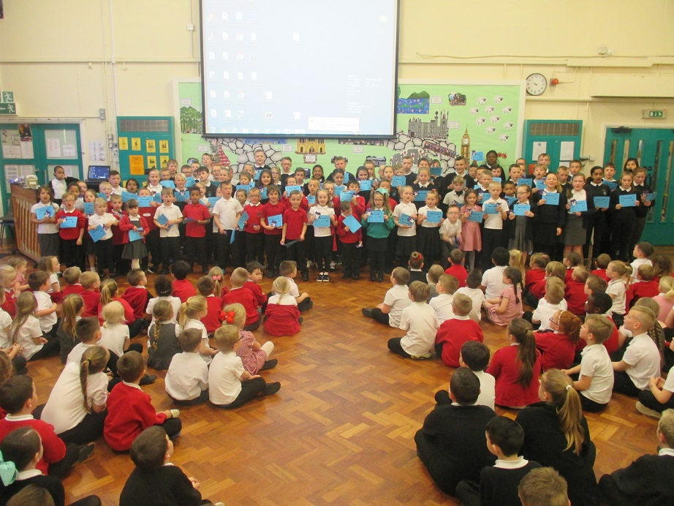

All these children achieved 95% attendance during terms 3 and 4, well done to them all.

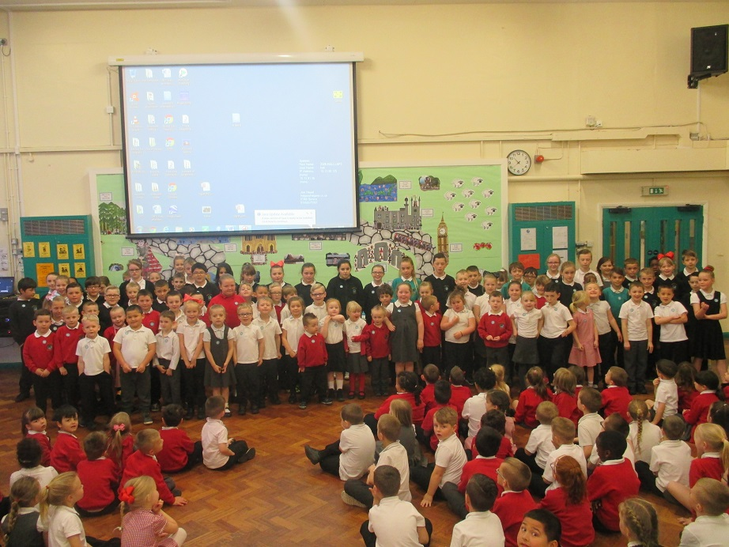

|  |  |
| --- | --- |
| **Merit awards awarded for outstanding achievement throughout term 4:**  **http://img.cdn.schooljotter2.com/sampled/2856830/600/NaN/framegreen/333333Enthusiasm:** Kyle Baxter; Brock Williams; Shayley Davis; Zack Phillips  **Challenge:** Alexis Pearce; Lily Rose Slane; Ford Griffin; Mya Willis; Macie Leigh Talbot; Lily Brace  **Learning Together:** Aaron Calder; Evie O’Connor; Becca Evans  **Respect:** Shamina Fennell;  **Trust:** Oliver Hamlin; Ruby Blackmore | |
| **Menu for the week beginning 24 April 2017 - Week 1**  **Monday:** Macaroni cheese : Cheese & tomato pizza : Salad bar  **Tuesday:** Roast gammon & roast pots : Cheese & red pepper frittata  **Wednesday:** Sausages & mash : Veggie sausages & mash : Salad bar  **Thursday:** Roast chicken & roast pots : Lentil & veg curry  **Friday:** Fishfingers & chips : French bread pizza & chips : Salad bar | |

|  |  |
| --- | --- |
| [https://encrypted-tbn1.gstatic.com/images?q=tbn:ANd9GcS2naC6_BGmcix327G2cuCRyieSHL3aT6EWNp3wj0SrhllF1oNUcQ](http://www.google.co.uk/url?sa=i&rct=j&q=&esrc=s&source=images&cd=&cad=rja&uact=8&ved=0CAcQjRw&url=http://www.blulana.com/tag/french-clip-art-images&ei=OyWoVPaWF8b_UPfFgsgL&bvm=bv.82001339,d.d24&psig=AFQjCNHFN6-eIch3s8hPVazKRfCHeeQXgw&ust=1420392127782547)**French Phrase of the week - KS2**  [https://encrypted-tbn1.gstatic.com/images?q=tbn:ANd9GcS2naC6_BGmcix327G2cuCRyieSHL3aT6EWNp3wj0SrhllF1oNUcQ](http://www.google.co.uk/url?sa=i&rct=j&q=&esrc=s&source=images&cd=&cad=rja&uact=8&ved=0CAcQjRw&url=http://www.blulana.com/tag/french-clip-art-images&ei=OyWoVPaWF8b_UPfFgsgL&bvm=bv.82001339,d.d24&psig=AFQjCNHFN6-eIch3s8hPVazKRfCHeeQXgw&ust=1420392127782547) | |
| Have a go speaking in French at home! It doesn’t matter how you sound, just try! These phrases are linked to the time of year or topics in school. | |
| **Ce n’est pas…**  **Ce n’est pas vert.** | **It is not..**  **It is not green.** |
| [https://encrypted-tbn1.gstatic.com/images?q=tbn:ANd9GcS2naC6_BGmcix327G2cuCRyieSHL3aT6EWNp3wj0SrhllF1oNUcQhttps://encrypted-tbn1.gstatic.com/images?q=tbn:ANd9GcS2naC6_BGmcix327G2cuCRyieSHL3aT6EWNp3wj0SrhllF1oNUcQ](http://www.google.co.uk/url?sa=i&rct=j&q=&esrc=s&source=images&cd=&cad=rja&uact=8&ved=0CAcQjRw&url=http://www.blulana.com/tag/french-clip-art-images&ei=OyWoVPaWF8b_UPfFgsgL&bvm=bv.82001339,d.d24&psig=AFQjCNHFN6-eIch3s8hPVazKRfCHeeQXgw&ust=1420392127782547)**French Word of the week – KS1** | |
| **violet** | **purple** |

**POLLING DAY SCHOOL CLOSURE – We have been informed that Fair Furlong will be used as a Polling Station on Thursday 4th May. Consequently school will be closed to YN – Y5. Y6 should come to school as normal in preparation for their SATs tests the following week. We will also be holding our Nursery Induction Day on this day.**

|  |
| --- |
| **First Response** – Are you a parent who needs support with a difficult issue, from your child’s behaviour to a problem related to domestic abuse? Are you a young person who needs to talk to someone about things that are worrying you? [www.bristol.gov.uk/page/children-and-young-people/first-response-bristol-report-concerns-about-child-social-worker 01179036444](http://www.bristol.gov.uk/page/children-and-young-people/first-response-bristol-report-concerns-about-child-social-worker%2001179036444)  Telephone number: 0117 9036444 |

**REMINDER – Sorry but there are NO after school clubs (including climbing) on THURSDAY 27TH APRIL due to staff training.**

**DATES FOR 2016/2017**

Monday 24 April Term 5 starts

Thursday 27 April **NO AFTER SCHOOL CLUBS!!!!!**

Monday 1 May **SCHOOL CLOSED – BANK HOLIDAY**

Thursday 4 May **Polling Day – School Closure for**

**YN – Y5 ONLY – Y6 in school as** **normal**

Monday 8th – Fri 12 May Y6 SATs

Wednesday 17 May Class Photos

Friday 26th May Last day of Term 5

Monday 5 June Term 6 starts

Monday 5-9 June Healthy & Safe Week

Monday 3 July Phase 3 Sports Morning

Tuesday 4 July Phase 2 Sports Morning

Thursday 6 July Reprts home

**Friday 7 July Inset Day**

Tuesday 11 July Y4/5/6 Performance

Wednesday 12 July Y4/5/6 Evening

Monday 17 July Open / World day

Thursday 20 July Last day of Term 6 (Friday 21 July Inset day – school closed to pupils)

**Inset days for school year 17/18**

4 & 5 September all children back Wednesday 6 Sep

Tuesday 2 January

Monday 23 Tuesday 24 July – Friday 20 July last day of term

**Lost Property - Will be on display in the small hall on Monday 24th April at 8.30 and 3.30.**

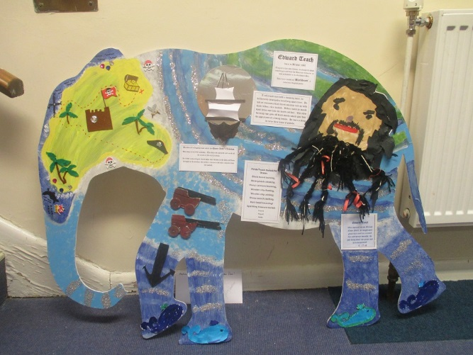**Enormous Elephant Trail**

**Sat 8th April to Sun 23rd April**

There are 40 wonderfully decorated elephants hiding in the shops in Broadmead and the Galleries waiting for you to discover them. Look out for our elephant that art club decorated along the way!!

There are also a range of activities for families throughout the Easter holidays please go to [www.faceboook.com/thearkbus](http://www.faceboook.com/thearkbus) Maps and information about the activities are available for download from:

<http://www.bristolshoppingquarter.co.uk/offers-and-whats-on/whats-on/2017/3/14/easter-elephants-heading-to-bristol-shopping-quarter-a4737>

<http://www.bristolshoppingquarter.co.uk/visitor-info/maps>

|  |
| --- |
| logoDear Hartcliffe community  Did you know that in September last year we welcomed1053 visitorsfrom Hartcliffeto At-Bristol? Thank you for all your help in making this happen. We are thrilled to be working with you again this year. Our **Hello Hartcliffe!** weekend will be on **20/21 May.** We will be having 6 *Hello! Community Open Weekends* - details and dates are on our website. We will also be distributing £4 tickets so that people can come back to At-Bristol at a time that suits them at a more affordable price |

**Letters this week – Phase Newsletters**

**Easter Challenges**

**Easter Elephant Trail**

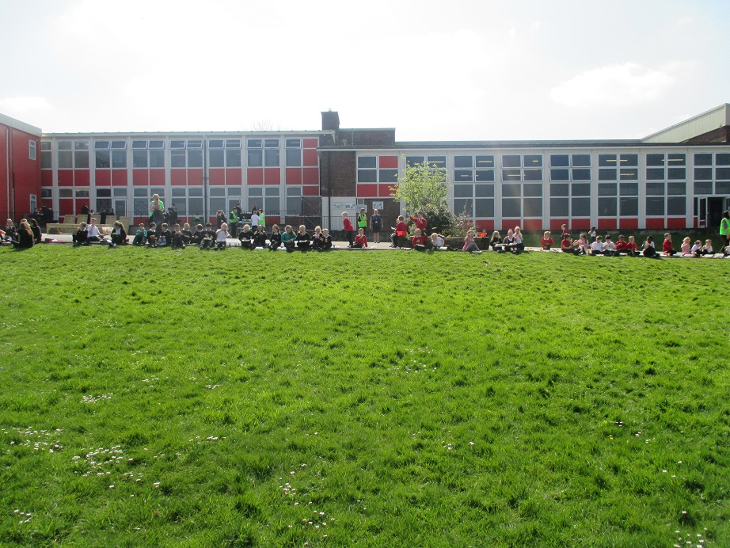**Lunch in the sun!!**